
We’ve got a Helluva Container for you!
24RECRSC3W
Used…but lots of life left!
48L x 40W x 24H – Rectangle
Top: Full Flap Bottom: Full Flap Walls: 3
Est. Units Per Pallet: 33 Est. Units Per Truckload: 1000
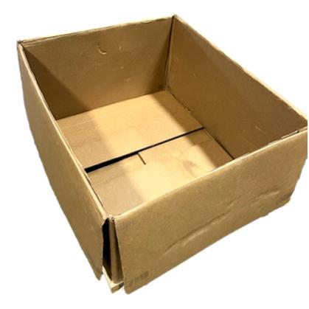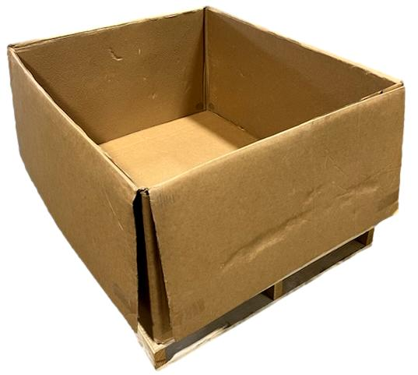
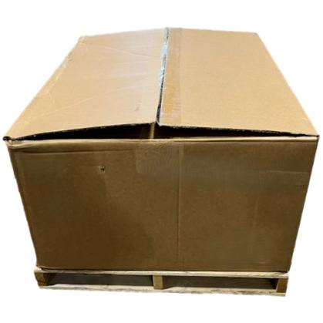
Call now & ask for the 24RECRSC3W.
You don’t want to miss this opportunity.
877.745.0311 HELLUVA.COM INFO@HELLUVA.COM

Images are representations. Actual box may vary.

